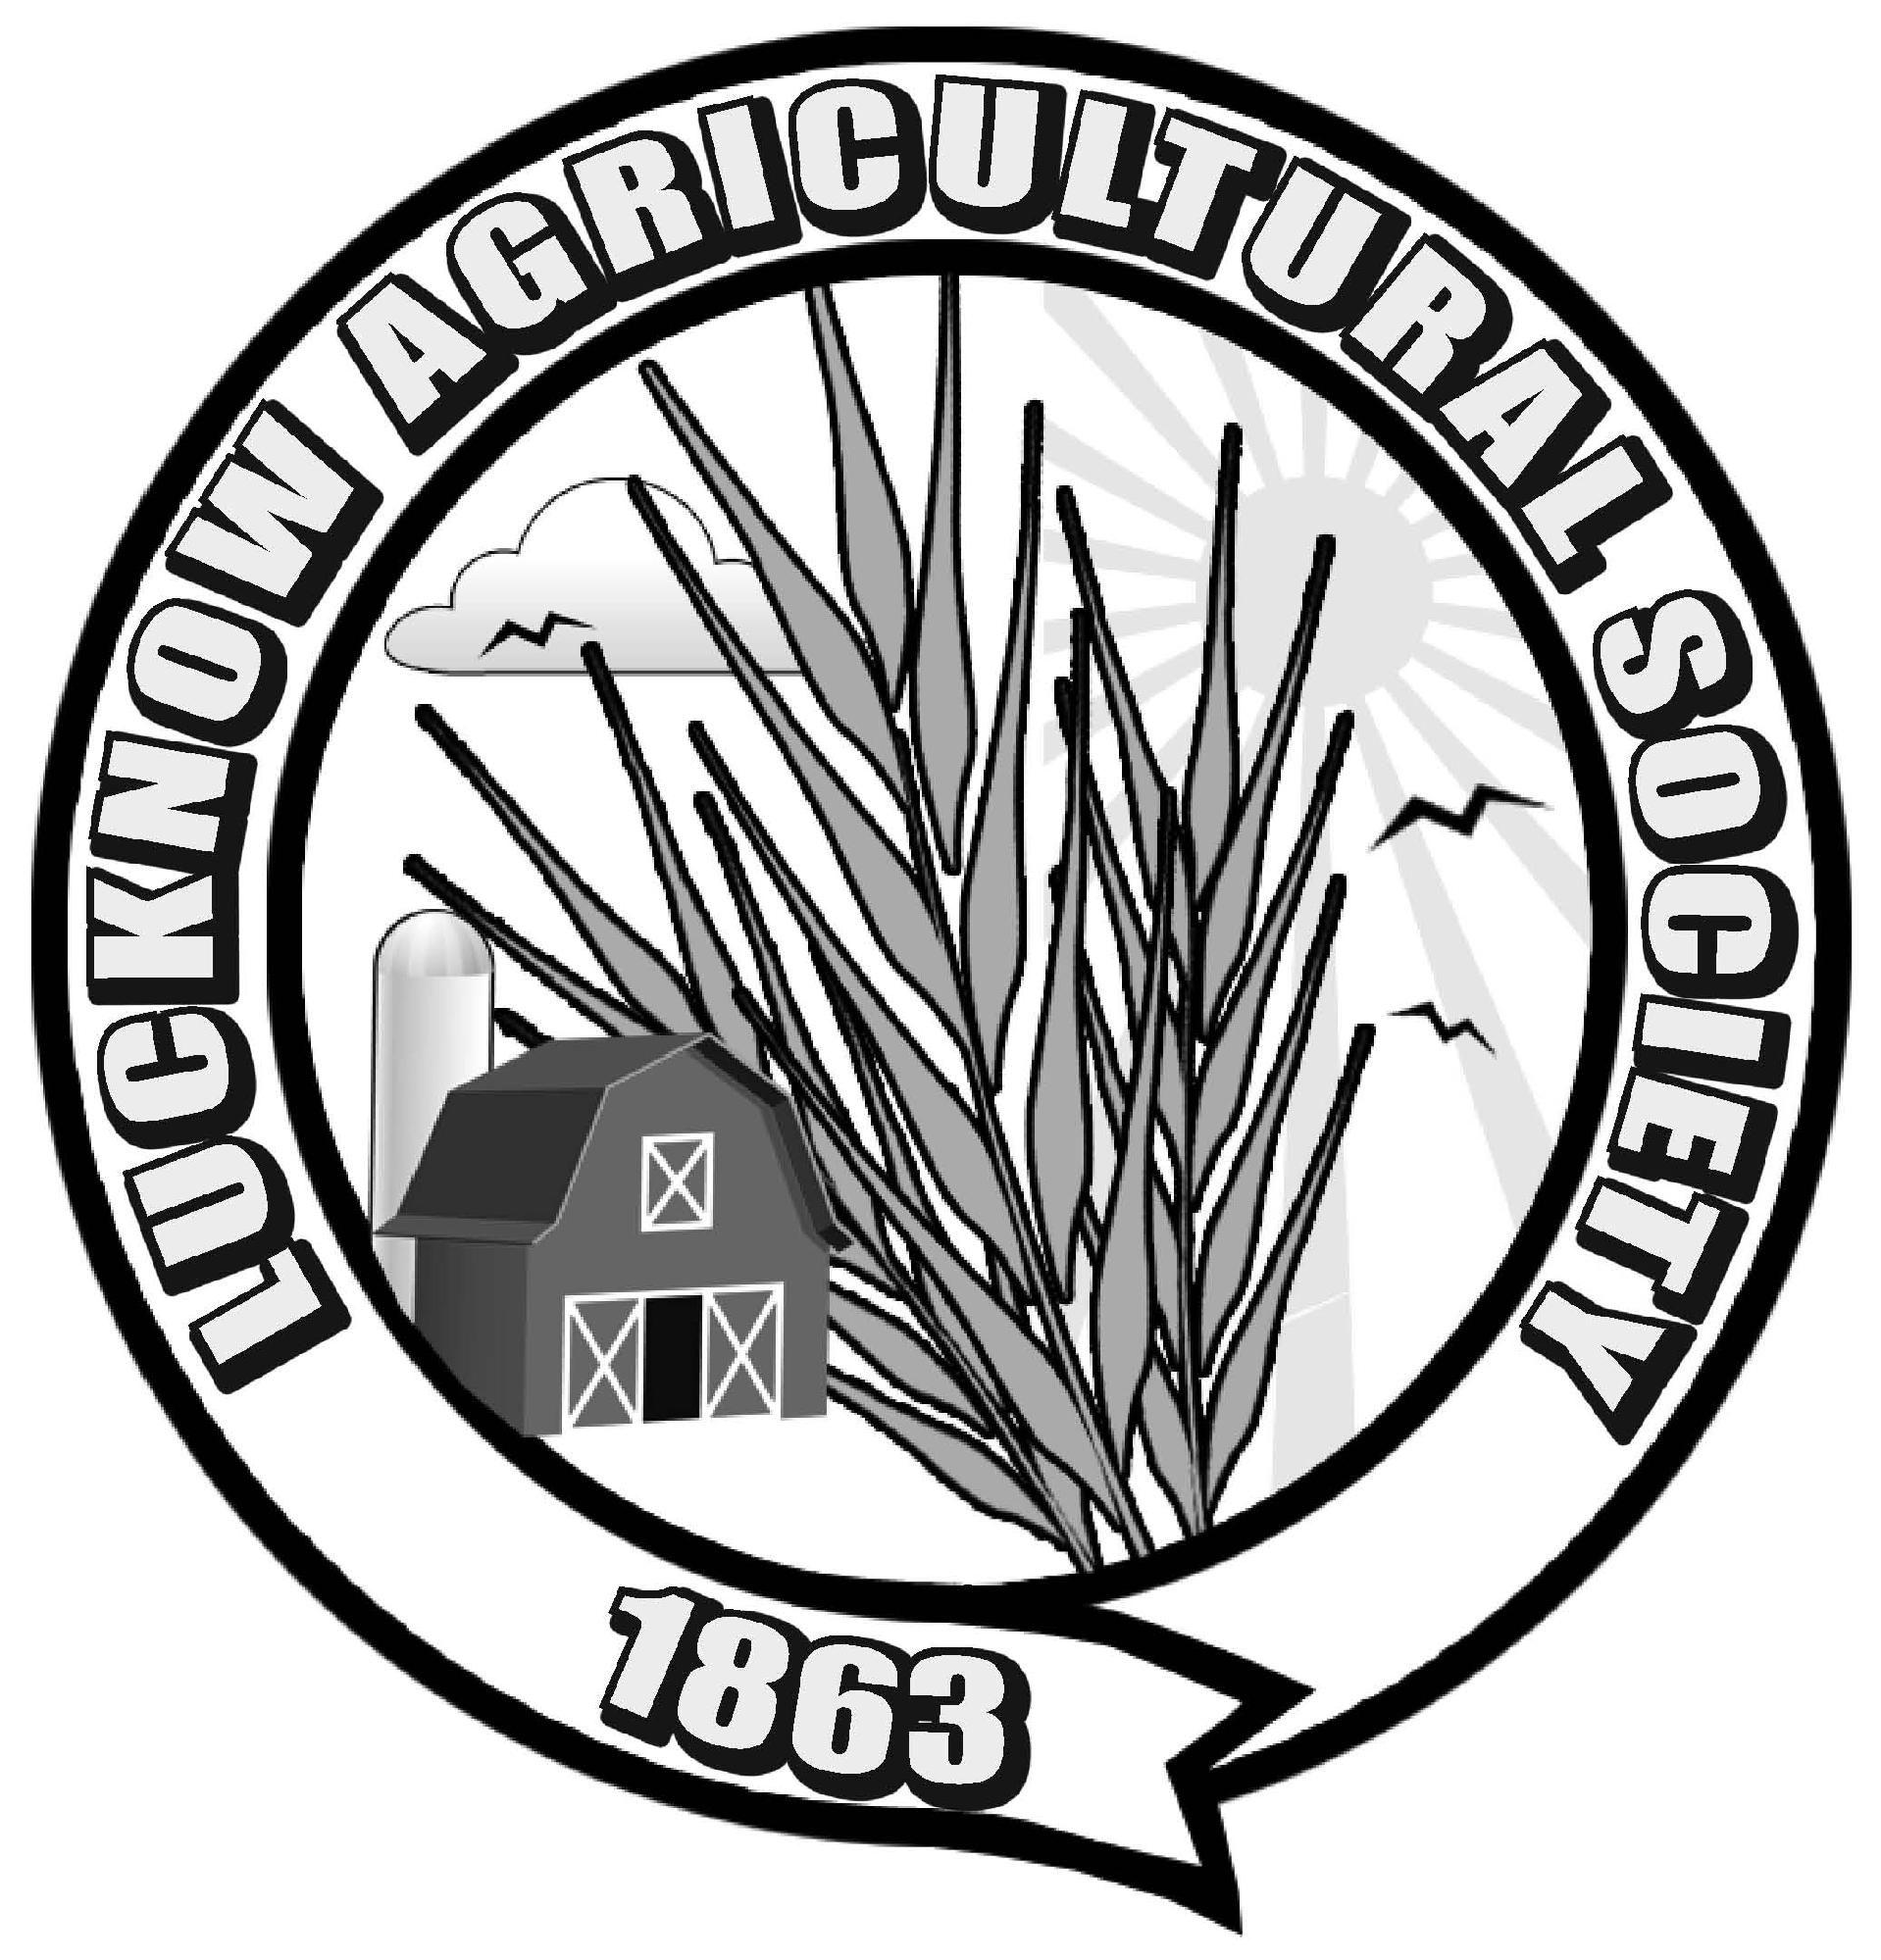
Planting Instructions
Peas-Little Marvel Pumpkins
64 Days to Harvest 95 Days to Harvest
Planting Depth 2.5 cm or 1” Planting Depth 2.5 cm or 1”
Seed Spacing 6 cm or 2.5” Seed Spacing 5-6 seeds per hill
Row Width 40 cm or 16”

Beans-Royal Burgundy Sweet Corn-Kandy Korn
54 Days to Harvest 83 Days to Harvest
Planting Depth 2.5 cm or 1” Planting Depth 2.5cm or 1”
Seed Spacing 8 cm or 3” Seed Spacing 15 cm or 6”
Row Width 50 cm or 20” Row Width 50 cm or 20”

Wild Flowers
Planting Depth 2.5 cm or 1”
Seed Spacing Scatter on the soil

Instructions for sunflower and carrots are included on the package.

Throughout the growing season we would like you to document the growing stages of your garden. Your poster will include a collage of pictures – planting the seeds, the growing stages and you eating/enjoying the vegetables from your garden. These posters will be displayed fall fair weekend!!!

Keep a pumpkin for the carving contest at Halloween
Thank you to Lucknow Co-op, Hodgins’ Home Hardware, Holyrood General Store, Fred Durnin & Edgar’s Feed and Seed for the seed donations!!
Good luck and Happy Gardening!!
Tag us in your progress pictures #LucknowFallFair and #SepoySpirit
Junior Section
Attention - Design a name tag with your first and last name on it. This tag will be used to display your entries. Be creative.
Each exhibitor will receive a prize of $10.00
Entries for 2021 Fall Fair – September 17 – 19, 2021
1) Sunflower with the biggest head
2) Tallest corn stalk must have at least 2 cobs
3) Egg carton animal
4) Painted pumpkin
5) Paper plate mask of a farm animal
6) Flower arrangement of wild flowers
7) 4 fun photos from over the past year, must be mounted on construction paper
8) Candy kabob
9) 3 chocolate chip cookies placed on a paper plate inside a Ziploc bag
10) Any subject, Any media, Any size
11) Create a poster board showing the growing process from seed to harvest from seeds that were donated
Note: For each child that is entering please have their smaller items grouped together in a bag if possible, for ease of placement with their Name Tag creation.

